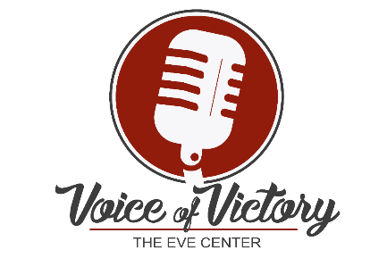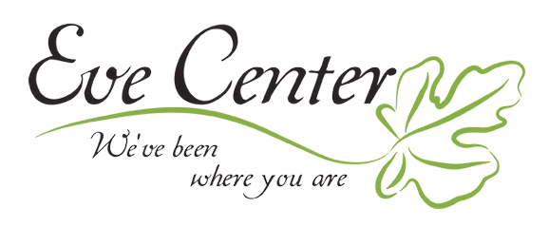
Dear ______________,
I am writing to you on behalf of Eve Center located here in Cincinnati. I am a volunteer peer counselor for this organization and it has my heart! The Eve Center is a non-profit organization dedicated to promoting healing and growth for women through biblical, no-cost, safe and confidential peer counseling and training. Eve Center desires for every hurting women to have access to emotional, relational and spiritual care that provides lasting hope!
I walk alongside women at Eve Center listening, encouraging, comforting and building into her right where she is because “We’ve Been There” too.
Eve Center is currently planning its largest and only event fundraiser this year, Voice of Victory 2020! It is much more than an event, it’s a CAUSE. We help women find their voices and process their deepest pain. This event speaks to who we are and what we do by showcasing local talent and hosting a vocal competition!
Money raised at the event will be used to serve our 1200+ clients a year across 3 locations.
We hope that (INSERT BUSINESS) might be willing to supply us with a suitable prize for our silent auction or basket raffle. (INSERT BUSINESS and suggested item) is always fabulous (INSERT WHAT THEY DO) but any suitable product you could donate to us would be much appreciated. We will give marketing credit to you and all donations are tax deductible!
If you were able to help, please coordinate with me to pick up your donation. All donations are due by October 1st so that we can upload them to our virtual auction site! If you require any more information please do not hesitate to contact me personally at (INSERT YOUR CONTACT INFO).
Thank you in advance from all of the volunteers and clients at Eve Center!
Warm Regards,
(INSERT YOUR NAME)

