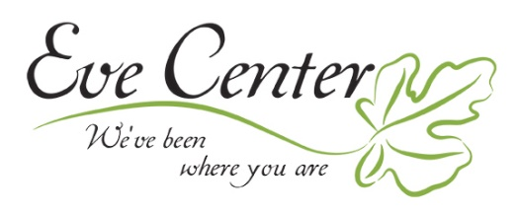

CODE OF PERFORMANCE FOR PARTICIPATING IN THE EVE CENTER VOCAL TALENT COMPETITION and GALA 2019

GENERAL RULES:
- All the finalists should be committed to the event fully and review the Eve Center “What We Stand For” section on our website, http://www.evecenter.org/816-2/
- The Finalists are expected to be on time and present for rehearsal on Friday, Nov. 1 at Sharonville Convention Center approx. 3:30pm and present for the entire competition from 6pm VIP Reception and 7-10pm Friday, Nov. 1, 2019.
- All finalists must be 18 years and older due to the nature of the organization and the population it serves. Male and Female contestants welcome!
- Finalists are from all denominations of churches. Please be respectful of all finalists and event attendees by not discussing specific churches and loyalties.
- All finalists should join, like and share about our event in your social networks. Including Instagram, Facebook, and Website. We want your supporters there to cheer you on and attend to vote for you!
- As part of the event promotion, the contestant gives the event Producer the right to use their name, likeness and biographical material to publicize the program and the services of the Producer. The Producer may: 1. Photograph and record the contestant’s voice and likeness for the purpose of the production mentioned above, whether by film, videotape, magnetic tape, digitally or otherwise; 2. Make copies of the photographs and recordings so made; 3. Use the contestant’s name and likeness for the purposes of education, promotion or advertising of the sale or trading in the photographs, recordings.

SPECIFIC RULES AND REGULATIONS FOR SINGING COMPETITION.
1. All vocalists must submit a final track for his or her performance to Sarah Robinson by October 1, 2019. .mp3
2. The performance time limit is 4 minutes MAX.
3. Accompanying instruments may be used. They must be acoustic.
4. The song should be based /reflected on The Eve Center’s “Voice of Victory” Theme for the year.
5. Accompanying vocalists may be present but must be approved by Sarah Robinson.
6. The song may be of any genre; however, all songs must be approved by Sarah Robinson, Talent Manager; no changes or substitutions of the initially approved song selection will be permitted without further approval by Gina Sanders (Event Director) at least 14 days in advance of the event.
7. Participants will be judged on vocal quality, authenticity, theme, diction, pitch, rhythm, expression, and presentation.
9. The vocalist securing first place will receive a check in the amount of $1000.00, to be mailed to contestant within 2 weeks of event date. The vocalist securing second place will receive a check for $500.00, to be mailed to contestant within 2 weeks of event date. The vocalist securing “Fan Favorite” will be contacted by a member of the Red’s organization regarding singing the National Anthem for the upcoming 2020 season.

10. The decision of the judges will be final and binding under all circumstances.
11. This document is binding and should be signed and returned to Sarah Robinson, by Sept. 11, 2019 to secure placement in the “VoV” competition 2019. If for any reason the contestant is unable to attend the rehearsal/soundcheck on the day of the event, contestant is disqualified from participation in the event.

Printed Name of Contestant ______________________________________________

SIGNATURE_____________________________________________date__________

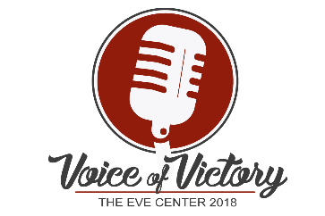
TALENT RELEASE FORM
I authorize the undersigned Producer to make use of my appearance on:
PROGRAM TITLE: Voice of Victory Gala and Talent Show
EVENT PRODUCER’S NAME: Eve Center
PRODUCER’S PHONE NUMBER: +1 (513) 985-9959
DATE OF EVENT: November 2, 2018
________________________ I understand that I am to receive no compensation for this appearance. The Producer shall have complete ownership of the program. I give the Producer the right to use my name, likeness and biographical material to publicize the program and the services of the Producer. The Producer may: 1. Photograph me and record my voice and likeness for the purpose of the production mentioned above, whether by film, videotape, magnetic tape, digitally or otherwise; 2. Make copies of the photographs and recordings so made; 3. Use my name and likeness for the purposes of education, promotion or advertising of the sale or trading in the photographs, recordings and any copies so made.
I further understand the master tape remains the property of the Producer and that there will be no restrictions on the number of times that my name and likeness may be used.
Name (please print)___________________________________ Date: _____________
Address ________________________________________________________________
City __________________________________ State ________ Zip Code ___________
Talent Signature____________________________________________________

