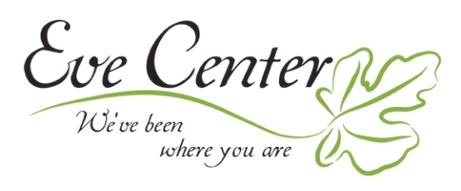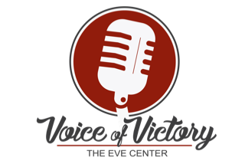
TALENT RELEASE FORM
I authorize the undersigned Producer to make use of my appearance on:
PROGRAM TITLE: Voice of Victory Vocal Talent Competition and Gala
EVENT PRODUCER’S NAME: Eve Center
PRODUCER’S PHONE NUMBER: +1 (513) 985-9959
DATE OF EVENT: November 1, 2019
________________________ I understand that I am to receive no compensation for this appearance. The Producer shall have complete ownership of the program. I give the Producer the right to use my name, likeness and biographical material to publicize the program and the services of the Producer. The Producer may: 1. Photograph me and record my voice and likeness for the purpose of the production mentioned above, whether by film, videotape, magnetic tape, digitally or otherwise; 2. Make copies of the photographs and recordings so made; 3. Use my name and likeness for the purposes of education, promotion or advertising of the sale or trading in the photographs, recordings and any copies so made.
I further understand the master tape remains the property of the Producer and that there will be no restrictions on the number of times that my name and likeness may be used.
Name (please print)___________________________________ Date: _____________
Address ________________________________________________________________
City __________________________________ State ________ Zip Code ___________
Talent Signature____________________________________________________

