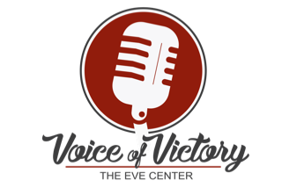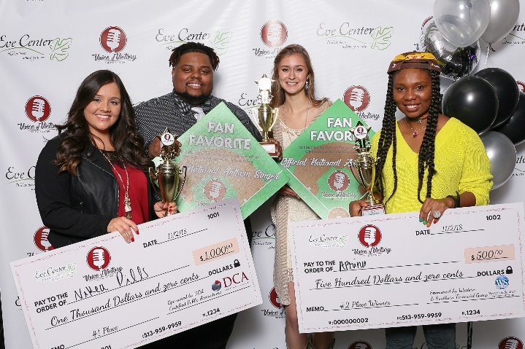
CALLING ALL VOCAL TALENT
Friday, November 1, 2019
7-10pm at the Sharonville Convention Center
Are you the SECOND “Eve Center VOICE”?
The Eve Center of Cincinnati is hosting its second annual VOICE of VICTORY 2019 talent competition and gala this fall and is seeking TOP VOCAL TALENT in the Tri-state region to compete for the $1000 GRAND prize and title of “The EC VOICE!”
2nd place, Runner up wins $500 prize.
And “Fan Favorite” will be voted by live audience to open for the Cincinnati REDS singing the National Anthem in 2020 season!

For more information… contact Gina Sanders at voiceevent@evecenter.org
or by cell at 513-706-2163.
All talent must submit an audition video (YouTube preferred) via voiceevent@evecenter.org by August 2, 2019, be 18 years of age or older, and agree to the Eve Center code of performance.
Visit evecenter.org for more information on the Eve Center of Cincinnati and Voice of Victory details.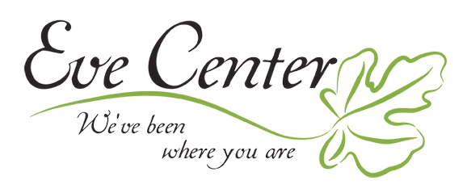
VOICE OF VICTORY 2019 FAQ’s
Who is the Eve Center of Cincinnati?
MISSION- To promote hope, healing and growth for all women 18+ through biblical, no cost, safe and confidential peer counseling and training.
VISION- The women of our community are following the source of true Hope, Jesus, and achieve and sustain emotional, relational, and spiritual health. Many choose to sacrifice their time to join us in empowering women toward healing and growth by becoming peer counselors to share what they have learned.
VALUES- Safety & Confidentiality, Respect, Acceptance, Validation, Grace & Forgiveness, Spiritual Maturity, and Biblical Truth.
Visit evecenter.org for more details.

Who should audition? Do I need to be female to participate?
NO! NO! NO! We love you too guys! Auditions are open to the general public, all residents of Ohio, Indianan and Kentucky, ages 18 and older! We are a female based organization but this is not a female ONLY event! We know we need our guys to support us too! Everyday! The organizers are looking for top talent of all genres who sing appropriate songs that celebrate the theme of “Victory” of all sorts!

The purpose of this Gala and Fundraiser?
“We are excited to host an event that exemplifies the core of what we do at the Eve Center of Cincinnati, help women find their voice and use it for victory in their everyday lives. The event promises to encourage all who attend, celebrate all we've accomplished in Cincinnati, and show our guests just how talented and amazing our Tri-state is,” Says Gina Sanders, Eve Center Director of Community Relations and Voice of Victory event lead. We are a non-profit, 501-3C and this is our annual gala and fundraiser to support the cost of doing the great work we do and speak to who we are in our community at the same time!

What’s the Event look like in format? How are applicant selected? And who are the judges?
The event organizers will select 5 finalists to perform at Sharonville Convention Center on November 1, 2019 for a live audience. A panel of local celebrity judges and gala guests will vote for their favorite artist and the first-place winner will be rewarded $1,000 and the runner up will receive $500. The “Fan Favorite” will be offered the opportunity to open with the National Anthem for the Cincinnati REDS! Our 2018 inaugural year sold out 3 weeks in advance at 300 guests. We have doubled the space this year and anticipate a sold-out crowd!
A diverse, unique, meaningful and high energy line up will be important to us! Show us your performance song in your audition video!
Who should Attend?
If performing live for an audience isn’t your forte, the event organizers invite you to sit back, relax and enjoy the entertainment, including dinner and a silent auction/raffle, as an attendee. The event will be a first-class production, featuring professional sound equipment to highlight the talented voices in our community. A Voice of Victory general admission ticket is $75 and available after May 31 online https://voiceevecenter.eventbrite.com
What benefits are offered to the contestants?
America’s Got Talent (like AGT… the NBC tv show) reached out to us for some of our talent contact information in 2018! One of our contestants was retweeted by Justin Bieber and has a substantial increased following! Google Osby Berry, You’re Welcome. Our Grand Prize Winner 2018
, Nikea Dills sang “Never Enough” from the movie/ musical The Greatest Showman, brought the house down and took home $1000. Not so bad?!

Each contestant has shared with us their connection to each other and support they have from their experience at this special event! It’s a game changer personally and professionally!

