## 

**SUMMER 2019 GROUPS & STUDIES**

**Session runs June 3rd – August 15th**

Register online by going to evecenter.org, click on services

and then Book Study. If you are already a Client

please call (513) 985-9959 to sign up

**Central Site**

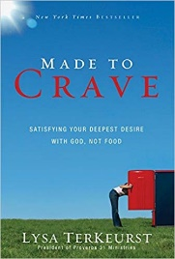

**Monday Evening 6:00 - 8:00 pm Starts June 3rd**

**Central Site location, 7038 Blue Ash Road, 45236**

**Made To Crave** - The reality is we were made to crave. Craving isn’t a bad thing. But we must realize God created us to crave more of him. This 7 week study will help you break the cycle of “I’ll start on Monday” and help you feel good about yourself today, stop agonizing over numbers on the scale and make peace with your body, give you wisdom that leads to victory and reach your healthy goals while growing closer to God through the process.

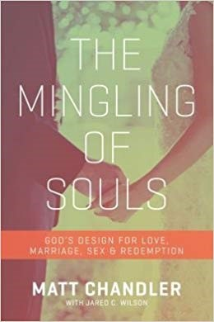

**Tuesday Evening 6:00 – 8:00 pm Starts June 4th**

**Central Site location, 7038 Blue Ash Road, 45236**

**The Mingling Of Souls -** The Song of Solomon offers strikingly candid—and timeless—insights on romance, dating, marriage, and sex. We need it. Because emotions rise and fall with a single glance, touch, kiss, or word. And we are inundated with songs, movies, and advice that contradicts God's design for love and intimacy. Matt Chandler helps navigate these issues for both singles and marrieds by revealing the process Solomon himself followed: Attraction, Courtship, Marriage ... even Arguing.

[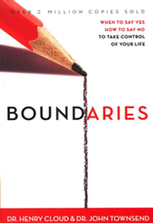](javascript:(function()%7bvar%20linkid%20=%20'Slideshow%20Link%20Additional%20Views';%7d)();)

**Wednesday Evening 6:00-8:00 pm Starts June 7th**

**Central Site location, 7038 Blue Ash Road, 45236**

**Boundaries-**Mark those things for which we are responsible. In other words, boundaries define who we are and who we are not. Are you living a life out of control? Are people taking advantage of you? Do you have trouble saying NO? Are you disappointed with God because of unanswered prayers? Often, Christians focus so much on being loving and unselfish that they forget their own limits and limitations. Join us to begin setting healthy boundaries for the first time or to brush up on your skills.

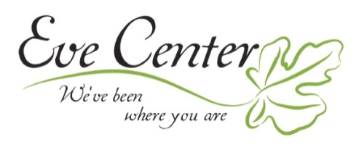

**SUMMER 2019 GROUPS & STUDIES**

**Session runs June 3rd – August 15th**

Register online by going to evecenter.org, click on services

and then Book Study. If you are already a Client

please call (513) 985-9959 to sign up

**West Site**

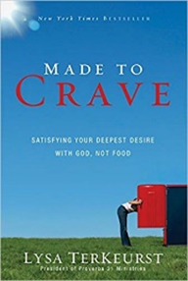

**Tuesday Evening 6:00 pm – 8:00 pm Starts June 4th**

**West Site location, 8575 Bridgetown Road, 45202**

**Made To Crave** - The reality is we were made to crave. Craving isn’t a bad thing. But we must realize God created us to crave more of him. This 7 week study will help you break the cycle of “I’ll start on Monday” and help you feel good about yourself today, stop agonizing over numbers on the scale and make peace with your body, give you wisdom that leads to victory and reach your healthy goals while growing closer to God through the process.

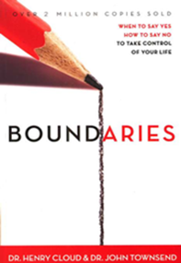

**Thursday Morning 10:00 am – 12:00 pm Starts June 6th**

**West Site location, 8575 Bridgetown Road, 45202**

**Boundaries-**Mark those things for which we are responsible. In other words, boundaries define who we are and who we are not. Are you living a life out of control? Are people taking advantage of you? Do you have trouble saying NO? Are you disappointed with God because of unanswered prayers? Often, Christians focus so much on being loving and unselfish that they forget their own limits and limitations. Join us to begin setting healthy boundaries for the first time or to brush up on your skills.



**SUMMER 2019 GROUPS & STUDIES**

**Session runs June 3rd – August 15th**

Register online by going to evecenter.org, click on services

and then Book Study. If you are already a Client

please call (513) 985-9959 to sign up

**North Site**

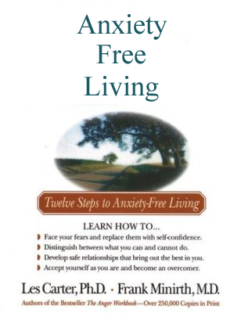

**Tuesday Evening 6:00-8:00 pm Starts June 4th**

**North Site location, 5962 Hamilton Mason Road, 45011**

**Anxiety Free Living -** Whether you call it stress, tension, frustration, or anxiety, worry can take its toll on health and well-being. It can be caused by life changes, such as divorce or career upheaval, or it can become a debilitating chronic disorder. "The Worry Workbook" helps readers understand what causes anxiety and how they can move beyond worry into emotional freedom. Practical steps, interactive exercises, checklists, and guided questions help readers identify their fears, replace negative talk with positive action, learn to accept what is out of their control, and make life-enhancing choices.

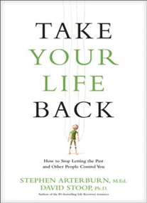

**Thursday Evening 6:00-8:00 pm Starts June 6th**

**North Site location, 5962 Hamilton Mason Road, 45011**

**Take Your Life Back** - Stop Letting The Past And Other People Control You:Does everyone else’s needs take precedence over yours? Is someone else's problem your problem? If, like so many others, you've lost sight of your own life in the drama of tending to someone else's, you may be codependent. A codependent is anyone who is dependent on another person to the point of being controlled or manipulated by that person. Exploring the concept of losing oneself in the name of helping another will help you learn to balance an unbalanced relationship. Learn how to stop controlling others and start caring for yourself and have a renewed commitment to put Christ first.



**SUMMER 2019 GROUPS & STUDIES**

**Session runs June 3rd – August 15th**

Register online by going to evecenter.org, click on services

and then Book Study. If you are already a Client

please call (513) 985-9959 to sign up

**HATCH: Healing Abuse Through Christ’s Help**

This 10-week Group helps women to be set free from shame, guilt, anger, and depression that accompany Sexual Abuse. The Eve Center HATCH program gives you a safe place to process the abuse and overcome the fear, mistrust, isolation, and irrational thoughts that often drive abuse victims.

This is a confidential group. For group day & time please contact

**HATCH@evecenter.org or call 513-985-9959**

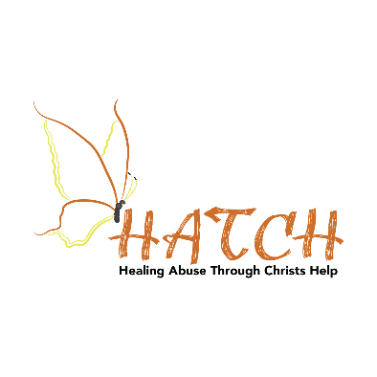

**HEART: Healing and Educating in Abortion Related Trauma**

This 10-week Program uses the book “Forgiven and Set Free” to guide women in dealing with the shame, guilt, and regret that plague the mind after an abortion. HEART gives women a safe and confidential place to heal.

This is a confidential group. For group day & time please contact

**HEART@evecenter.org or call 513-985-9959**



**ROSE: Relationships Overcoming Struggles through Encouragement**

This 10- week recovery group is for women in dysfunctional relationships who need a sense of direction to be equipped to begin and maintain healthy relationships.

This is a confidential group. For group day & time please contact

**ROSE@evecenter.org or call 513-985-9959**

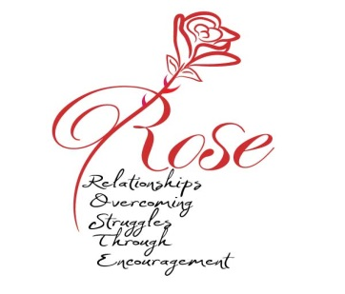

**GOLD: God Overcomes Loss from Death**

The death of a loved one will change life forever. No one can foresee how radically the future is altered. ‘GOLD is a 10-week group for women lost in the grief process. Engage with others through your unique stories of grief; explore the emotional impact and questions such as ‘what is grief’, ‘why’, and ‘what now’. We will challenge God and be transformed by Christ.

This is a confidential group. For group day & time please contact

**GRIEF@evecenter.org or call 513-985-9959**

