## 

**FALL 2018 GROUPS & STUDIES**

**Session runs September 11th – November 15th**

Register online by going to evecenter.org, click on services

and then Book Study. If you are already a Client

please call (513) 985-9959 to sign up

**Central Site**

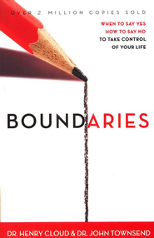

**Tuesday Morning 10:00 - 12:00 pm Starts September 11th**

**Central Site location, 7038 Blue Ash Road, 45236**

**Boundaries-Part 1, Personal Property Lines -** mark those things for which we are responsible. In other words, boundaries define who we are and who we are not. Are you living a life out of control? Are people taking advantage of you? Do you have trouble saying NO? Are you disappointed with God because of unanswered prayers? Often, Christians focus so much on being loving and unselfish that they forget their own limits and limitations. Join us to begin setting healthy boundaries for the first time or to brush up on your skills.

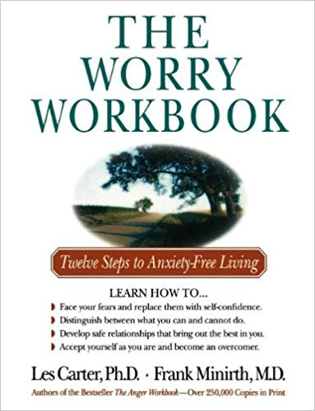

**Tuesday Evening 6:00-8:00 pm Starts September 11th**

**Central Site location, 7038 Blue Ash Road, 45236**

**Anxiety Free Living** - Whether you call it stress, tension, frustration, or anxiety, worry can take its toll on health and well-being. It can be caused by life changes, such as divorce or career upheaval, or it can become a debilitating chronic disorder. "The Worry Workbook" helps readers understand what causes anxiety and how they can move beyond worry into emotional freedom. Practical steps, interactive exercises, checklists, and guided questions help readers identify their fears, replace negative talk with positive action, learn to accept what is out of their control, and make life-enhancing choices.

[Take Your Life Back: How to Stop Letting Your Past and Other People Control You  -     By: Stephen Arterburn, David Stoop
](javascript:(function()%7bvar%20linkid%20=%20'Slideshow%20Link%20Additional%20Views';%7d)();)

**Thursday Evening 6:00-8:00 pm Starts September 13th**

**Central Site location, 7038 Blue Ash Road, 45236**

**Stop Letting The Past And Other People Control You -** Does everyone else’s needs take precedence over yours? Is someone else's problem your problem? If, like so many others, you've lost sight of your own life in the drama of tending to someone else's, you may be codependent. A codependent is anyone who is dependent on another person to the point of being controlled or manipulated by that person. Exploring the concept of losing oneself in the name of helping another will help you learn to balance an unbalanced relationship. Learn how to stop controlling others and start caring for yourself and have a renewed commitment to put Christ first.

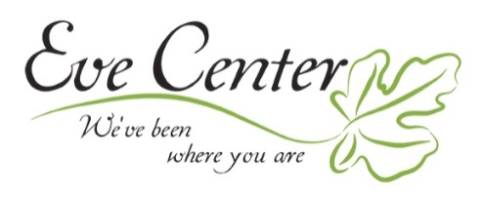

**FALL 2018 GROUPS & STUDIES**

**Session runs September 11th – November 15th**

Register online by going to evecenter.org, click on services

and then Book Study. If you are already a Client

please call (513) 985-9959 to sign up

**Session runs June 12th - August 23rd**

**Register online by going to evecenter.org, click on services and then Recovery Group. If you are already a Client please call (513) 985-9959 to sign up.**

**West Site**



**Tuesday Evening 6:00-8:00 pm Starts September 11th**

**West Site location, 8575 Bridgetown Road, 45202**

**Boundaries-Part 1, Personal Property Lines -** mark those things for which we are responsible. In other words, boundaries define who we are and who we are not. Are you living a life out of control? Are people taking advantage of you? Do you have trouble saying NO? Are you disappointed with God because of unanswered prayers? Often, Christians focus so much on being loving and unselfish that they forget their own limits and limitations. Join us to begin setting healthy boundaries for the first time or to brush up on your skills.

Safe People: How to Find Relationships That Are Good for You and Avoid Those That Aren't  -     By: Henry Cloud, John Townsend


**Tuesday Evening 6:00-8:00 pm Starts September 11th**

**West Site location, 8575 Bridgetown Road, 45202**

**Finding Healthy Relationships -** Do your "people connections" lift you up or drag you down? If you often make "wrong" choices in love, work, or friendships, you *can* learn to find people who are good for you! Cloud and Townsend identify traits of untrustworthy people, offer practical strategies for forming healthy associations, and reveal things about yourself that jeopardize relationships



**FALL 2018 GROUPS & STUDIES**

**Session runs September 11th – November 15th**

Register online by going to evecenter.org, click on services

and then Book Study. If you are already a Client

please call (513) 985-9959 to sign up

**North Site**

[Take Your Life Back: How to Stop Letting Your Past and Other People Control You  -     By: Stephen Arterburn, David Stoop
](javascript:(function()%7bvar%20linkid%20=%20'Slideshow%20Link%20Additional%20Views';%7d)();)

**Tuesday Evening 6:00-8:00 STARTS Sept 11th**

**North Site location, 5962 Hamilton Mason Road, 45011**

**Stop Letting The Past And Other People Control You -** Does everyone else’s needs take precedence over yours? Is someone else's problem your problem? If, like so many others, you've lost sight of your own life in the drama of tending to someone else's, you may be codependent. A codependent is anyone who is dependent on another person to the point of being controlled or manipulated by that person. Exploring the concept of losing oneself in the name of helping another will help you learn to balance an unbalanced relationship. Learn how to stop controlling others and start caring for yourself and have a renewed commitment to put Christ first.

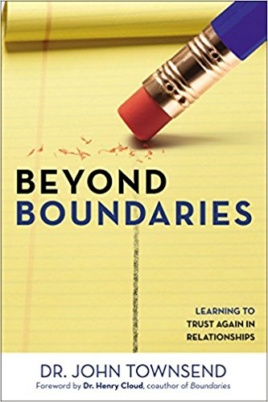

**Thursday Evening 6:00-8:00 STARTS September 13th**

**North Site location, 5962 Hamilton Mason Road, 45011**

**Learning To Trust Again In Relationships** - How do you know you’re ready to trust again … and what does it take to be ready? Painful relationships violate our trust, causing us to close our hearts. But to experience the freedom and love God designed us for, we eventually have to take another risk. In this breakthrough book, bestselling author Dr. John Townsend takes you beyond the pain of the past to discover how to re-enter a life of intimate relationships. Whether you’re trying to restore a current relationship or begin a new one, Townsend gives practical tools for establishing trust and finding the intimacy you long for.

.



**FALL 2018 GROUPS & STUDIES**

**Session runs September 11th – November 15th**

Groups are Confidential. Please call Eve Center to find out specific details. Register online by going to evecenter.org, click on services and then Recovery Group. If you are already a

Client please call (513) 985-9959 to sign up.

**HATCH: Healing Abuse Through Christ’s Help**

This 10-week Group helps women to be set free from shame, guilt, anger, and depression that accompany Sexual Abuse. The Eve Center HATCH program gives you a safe place to process the abuse and overcome the fear, mistrust, isolation, and irrational thoughts that often drive abuse victims.

This is a confidential group. For group day & time please contact

**HATCH@evecenter.org or call 513-985-9959**

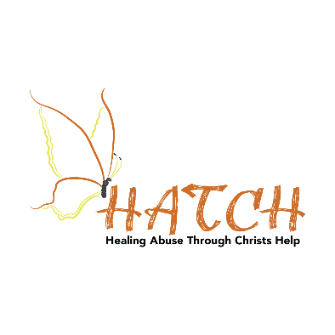

**HEART: Healing and Educating in Abortion Related Trauma**

This 10-week Program uses the book “Forgiven and Set Free” to guide women in dealing with the shame, guilt, and regret that plague the mind after an abortion. HEART gives women a safe and confidential place to heal.

This is a confidential group. For group day & time please contact

**HEART@evecenter.org or call 513-985-9959**



**ROSE: Relationships Overcoming Struggles through Encouragement**

This 10- week recovery group is for women in dysfunctional relationships who need a sense of direction to be equipped to begin and maintain healthy relationships.

This is a confidential group. For group day & time please contact

**ROSE@evecenter.org or call 513-985-9959**

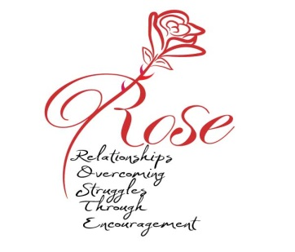

**SEED: Support & Encouragement for Eating Disorders**

Would you like to be free from bondage to food and body image? This 10-week group provides weekly support coupled with daily personal study time to provide the tools necessary for hope and healing.

This is a confidential group. For group day & time please contact

**SEED@evecenter.org or call 513-985-9959**

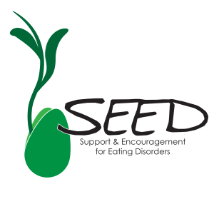

**GOLD: God Overcomes Loss from Death**

The death of a loved one will change life forever. No one can foresee how radically the future is altered. ‘GOLD is a 10-week group for women lost in the grief process. Engage with others through your unique stories of grief; explore the emotional impact and questions such as ‘what is grief’, ‘why’, and ‘what now’. We will challenge God and be transformed by Christ.

This is a confidential group. For group day & time please contact

**GRIEF@evecenter.org or call 513-985-9959**

